**Q1 (2 points)**

You are asked to write a console application named Q1 which allow user to enter the fruit name to search and replace and display it as below

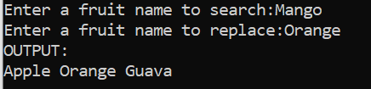

Your Main() function as below:

static void Main(string[] args)

{

string[] msg = { "Apple", "Mango", "Guava"};

Console.Write("Enter a fruit name to search:");

string search = Console.ReadLine();

ref string fruit = ref find(search, msg);

Console.Write("Enter a fruit name to replace:");

string replace = Console.ReadLine();

if(fruit == search) fruit = replace;

Console.WriteLine("OUTPUT:");

Console.WriteLine(string.Join(" ", msg));

Console.ReadLine();

}

Your task is to create the following function:

static ref string find(string s, string[] ls);

**Q2 (2 points)**

You are asked to write a console application named Q2 which allow user to enter and display the list of foods as below

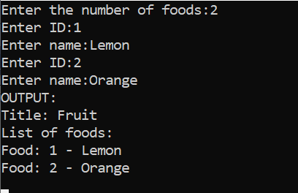

Your tasks include several of following steps:

1. Create a Food class contains:
   1. Two attributes: id (int) and name (string).
   2. Necessary constructors.
2. Create a Foods class contains:
   1. Two attributes: foodTile (string) and listOfFoods (List<Food>).
   2. Necessary constructors.
   3. Override method ToString().

Your main function should look like as below:

static void Main(string[] args)

{

List<Food> fl = new List<Food>();

int numberFoods;

Console.Write("Enter the number of foods:");

numberFoods = int.Parse(Console.ReadLine());

for (int i=0; i<numberFoods; i++)

{

Food food = new Food();

Console.Write("Enter ID:");

food.Id = int.Parse(Console.ReadLine());

Console.Write("Enter name:");

food.Name = Console.ReadLine();

fl.Add(food);

}

Foods foods = new Foods("Fruit", fl);

Console.WriteLine("OUTPUT:");

Console.Write(foods);

Console.ReadLine();

}

**Q3 (3 points)**

You are asked to write a console application named Q3 which allow user to enter information of Student’s object and display it as below

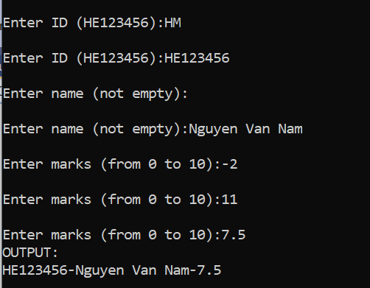

Your tasks include several of following steps:

1. Create a interface IUility contains:

a) float GetFloat(string msg, float min, float max);

b) string GetString(string msg, string pattern);

2. Create a Utility class to implement interface IUtility.

3. Create a Student class contains:

a) 3 data fields: id (string), name (string), and marks (float).

b) Override method ToString().

Your program will allow user to enter information of a student:

* ID is a string of 8 characters, begins with “HE” and followed by 6 digits (from 0 to 9). Otherwise the user must enter again.
* Name is not empty, otherwise the user must enter again.
* Marks is a float from 0 to 10, otherwise the user must enter again.

Your main function should look like as below:

static void Main(string[] args)

{

Student s = new Student();

Utility utility = new Utility();

s.Id = utility.GetString("Enter ID (HE123456):", @"^[H][E]\d{6}$");

s.Name = utility.GetString("Enter name (not empty):", @"\S+");

s.Marks = utility.GetFloat("Enter marks (from 0 to 10):", 0, 10);

Console.WriteLine("OUTPUT:");

Console.WriteLine(s);

Console.ReadKey();

}

**Q4 (3 points)**

You are asked to write a console application named Q4 which allow user to enter the array of students, sort by marks ascending, name descending, and display it as below

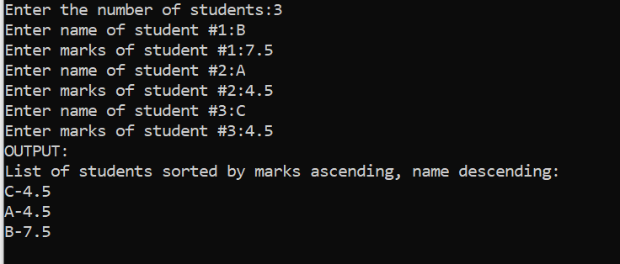

Your tasks include several of following steps:

1. Create a Student class contains:

a) 2 data fields: name (string), and marks (float).

b) Override method ToString().

2. Create a sortByMarksNameDesc class to implement interface IComparer<Student>

Your main function should look like as below:

static void Main(string[] args)

{

int nS, i;

Console.Write("Enter the number of students:");

nS = int.Parse(Console.ReadLine());

Student[] ls = new Student[nS];

for (i = 0; i < nS; i++)

{

ls[i] = new Student();

Console.Write("Enter name of student #{0}:", i+1);

ls[i].Name = Console.ReadLine();

Console.Write("Enter marks of student #{0}:", i+1);

ls[i].Marks = float.Parse(Console.ReadLine());

}

Array.Sort(ls, new sortByMarksNameDesc());

Console.WriteLine("OUTPUT:");

Console.WriteLine("List of students sorted by marks ascending, name descending:");

foreach (Student s in ls)

Console.WriteLine(s);

Console.ReadKey();

}